# AcqManager

# Main Frame Guide (*Data Acquisition*)

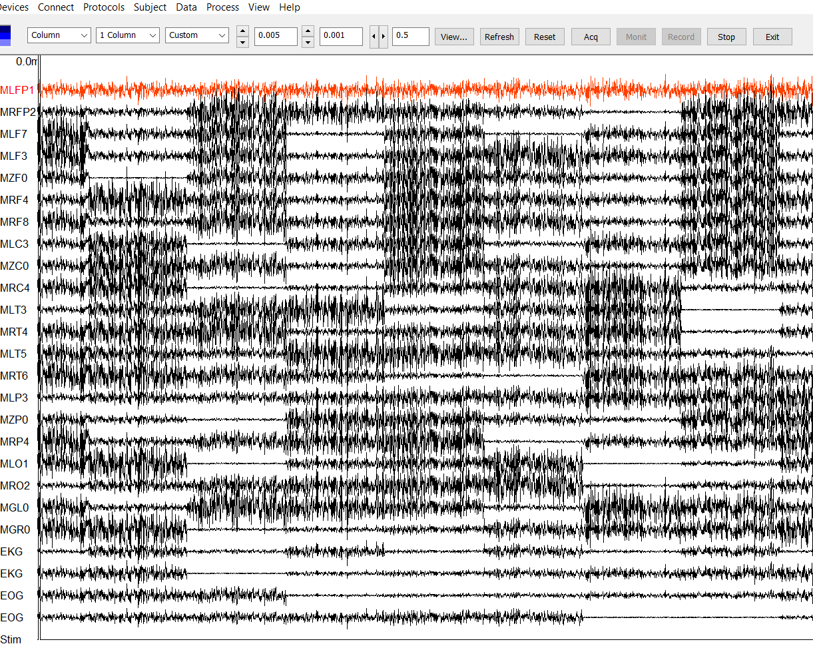

# DISCLAIMER

We have used reasonable effort to include accurate and up-to-date information in this manual; it does not, however, make any warranties, conditions or representations as to its accuracy or completeness. We assume no liability or responsibility for any errors or omissions in the content of this manual. Your use of this manual is at your own risk. Under no circumstances and under no legal theory shall the authors be liable for any indirect, direct, special, incidental, punitive, exemplary, aggravated or consequential damages arising from your use of this manual.

Features and specifications of this software program are subject to change without notice. This manual contains information and images about AcqManager, its user interface, GUI and its other signal processing algorithms, publications that are protected by copyright.

All rights reserved. This publication may be reproduced, stored in a retrieval system, or transmitted, in any form or by any means, electronic, mechanical, photocopying, recording, or otherwise, with prior permission by the authors.

*Sending Your Comments and Critiques:* We’d like to hear from you. Your comments and suggestions for improving this document are welcome and appreciated. Please e-mail your feedback to support@mecurer.com

Thank you.

Contents

*Warnings and Cautions* 4

Preface 5

Using AcqManager Main Frame 6

Environment Variables 6

Launching AcqManager 7

Selecting Devices (Data Acquisition Cards) 7

Supported Devices (tested systems) 7

Customizing the Layout 9

Displaying Channels 9

Channel Types 10

Sensor and Reference Channels 11

Continuous Head Localization Data 12

Displaying Channel Sets 12

User-defined Channel Sets 12

Displaying Channel Groups 12

Channel Selection Dialog 12

Selecting Channel Groups 13

Scaling the Time Axis 13

Scaling the amplitude of waveforms 13

Dialog for waveform display settings 14

Define a range for viewing 14

Define background and other parameters 14

Acquisition, Monitor and record 14

MEG/EEG Montages (CxC) 15

# *Warnings and Cautions*

This software supports data acquisition for magnetoencephalography (MEG), electroencephalography (EEG) and other bioelectromagnetic signals. Though MEG and EEG waveforms appear similar, they have different unit in amplitude. If the MEG and EEG data recorded simultaneously, their time unit or temporal resolution is typically the same.

Modern MEG/EEG systems typically have MEG/EEG sensor/electrode channels as well as other channels. For example, trigger channel, head-localization channels and additional ADC (analog-to-digital) channels. To avoid problems, please pay attention to the channel names and the amplitude value/unit. Their values may be of different orders of magnitude. Unexpected results may occur if their values are mixed in measurements.

When performing waveform analysis, regardless of whether MEG or EEG or both are displayed, ensure that the data are appropriately filtered with DC-offset/linear-trend removal. If the waveforms had very large amplitude (e.g. > 3 pt), it is recommended that you identify possible noise.

There are a set of source localization algorithms in the program. Each source localization algorithm has been designed and tested for specific reasons. To ensure the quality and visibility, all source localization algorithms will generate a volumetric source image, which can be considered as an image with millions of “dipoles” or multi-value-voxel, which is significantly different from the conventional magnetic source imaging (MSI) or equivalent current dipoles.

Head movement during MEG recordings may affect the accuracy of source imaging. If subjects move too much during MEG recordings, the MEG results are more than likely poor.

The accuracy of the structural images (MRI/CT) may also affect the MEG results if the conventional magnetic source imaging (MSI) is used. If MRI/CT is distorted, the combination of MEG/MRI/CT will be low-quality. In addition, multiple local sphere, head model or other structural constrained source localization my internally use the MRI/CT images. Any analysis based on those distorted images may yield unexpected or poor results.

The following warnings and cautions appear in this guide. Please ensure you are aware of all the operations and interpretations.

# Preface

The Main Frame is one of the core windows of AcqManager software. It is used as the primary tool to view MEG, EEG, MCG, ECG, triggers and other data, mark and classify the data, and identify results of interest for academic or clinical purposes. Importantly, the Main Frame provides graphic user interface (GUI) for access other function. In other words, it is also often used to launch other windows such as source localization.

This guide describes the operation of the AcqManager application for MEG/EEG/MCG/ECG. Though there are many functions related to MRI/CT, analyses of MRI/CT are not the focuses of this guide.

*Determining the Software Version*

In the Main Frame: select Help -> About.

The About Dialog will show the version of the software.

*Intended Audience*

This guide is intended for anyone needing to record and view (online) data with an appropriate hardware system. It assumes the technologist/operator is familiar with standard MEG/EEG/MCG/ECG procedures and with the Windows operating systems.

*Document Structure*

Documents are generally provided in both Microsoft Word® format and Adobe® Acrobat® PDF (Portable Document Format). All editions are distributed on Flash Driver, CD or websites with the related software, and include bookmarks and hyperlinks to assist navigating the document. Please feel free to send your critiques, corrections, suggestions and comments to support@mecurer.com.

*Conventions*

Numeric: Numeric values are generally presented in decimal but in special circumstances may also be expressed in hexadecimal or binary. Hexadecimal values are shown with a prefix of 0x, in the form 0x3D. Binary values are shown with a prefix of 0b, in the form 0b00111101. Otherwise, values are presumed decimal.

Units: Units of measure are given in metric. Where measure is provided in imperial units, they are typically shown in parenthesis after the metric units. Biomagnetic signal strength is given in Teslas (T), the SI unit of flux density (or field intensity) for magnetic fields, also known as the magnetic induction. Typical signal strengths in biomagnetic measurements are in the order of pT (picoteslas = 10-12) or fT (femtoteslas = 10-15). Electrical signal strength is given in volts (V). Bioelectrical activity is typically quite small, measured in microvolts (mV).

# Using AcqManager Main Frame

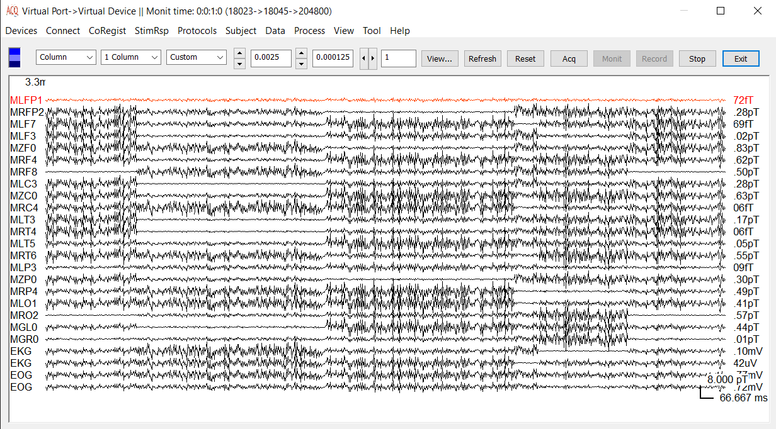Figure 1. AcqManager Main Frame and Waveform Viewer (during MEG recordings).

Waveform viewer in the middle of main frame is used to review biomagnetic signal during MEG and EEG recording. You can display data simultaneously as individual traces, overlaid traces, and in colored contour map format. Channels can be viewed on a trial-b y-trial basis or all at once in both the time and time-frequency domains. Display settings are automatically saved and can be used to recreate a particular setup with other data of the same study type.

The waveform viewer provides various ways to check data points and to classify trials. The waveform viewer also allows you to analyze the data to identify and mark areas of interest for research or clinical purposes. This chapter explains how to get started with data acquisition and shows how to use its main monitoring, viewing and checking functions.

# Environment Variables

AcqManager has its own file format. When a file is recorded at the first time, you may need to decide where to store the recorded file to AcqManager. To be safe, please do not over-write the previous recorded file.

# Launching AcqManager

Similar to many other software programs on Windows, AcqManager can be launched by simply clicking “AcqManager.exe” file or any short-cuts linked to it.

# Selecting Devices (Data Acquisition Cards)

The software supports an increasing list of devices (data acquisition card) or hardware or systems:

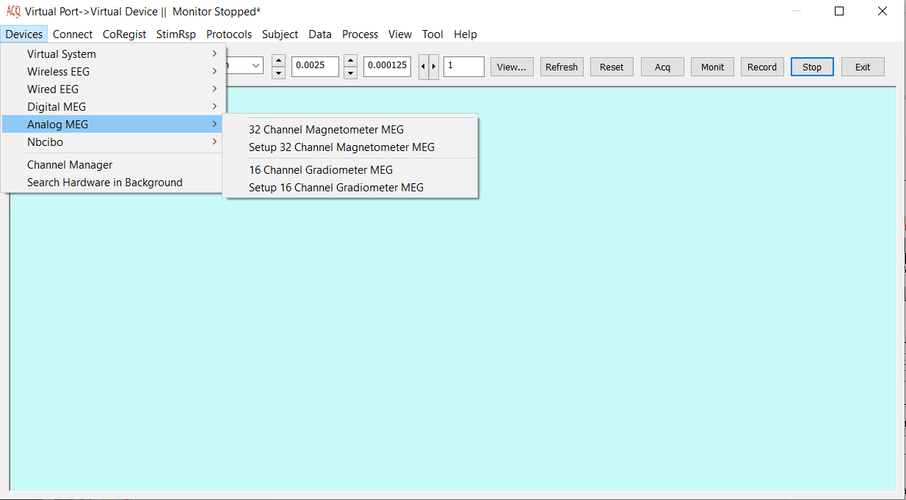Figure 2. GUI for opening/importing MEG Dataset.

(1) Select Menu “Devices”-> Select Type of devices->Sub-model

For example: Devices->OpenBci->Daisy 16c EEG System

(2) Setup the device if the device was just installed or modified. It is recommended for first time usage.

# Supported Devices (tested systems)

AcqManager can a set of bioelectromagnetic systems. Biomagnetic (e.g. MEG) systems are typically more complicated than bioelectric (EEG) systems. Following systems are commonly used in research and clinical environments.

(1)Virtual System: This category does not need to install any devices or hardware. The computer will simulate a virtual MEG or EEG system for data acquisition or recordings. The recorded data can be viewed, edited and analyzed.

OPM 21c MEG System: this device is a virtual MEG system, with 21 channels of magnetic sensors based on optically pumped magnetometer (OPM).

Wireless 21c EEG System: this device is a virtual EEG system, with 21 channels of electrodes connected wirelessly to the data acquisition card.

(2)OpenBci: OpenBci stands for open-source brain-computer interface (BCI). The devices provide anyone with a computer, the tools necessary to sample the electrical activity of the human body. The biosensing systems can be used to sample electrical brain activity (EEG), muscle activity (EMG), heart rate (ECG), body movement, and much more.

AcqManager provide the optimal, versatile and affordable graphic user interface to record EEG signals with Bluetooth or Wifi (Wi-Fi).

Cyton8c EEG System: this device is an EEG system, with 8 channels of electrodes connected to computer with Bluetooth (a USB Bluetooth to Com port).

Daisy16c EEG System: this device is an EEG system, with 16 channels of electrodes connected to computer with Bluetooth.

Cyton8w EEG System: this device is an EEG system, with 8 channels of electrodes connected wirelessly to computer with Wifi.

Cyton16w EEG System: this device is an EEG system, with 16 channels of electrodes connected wirelessly to computer with Wifi.

(3)QuSpin: QuSpin provides the devices to take extreme field sensing from the lab to the real world. QuSpin magnetic sensors are non-cryogenic alternative to superconducting magnetometers, which are based on OPM. The optical magnetometers are extremely sensitive, easy to use.

QZFM Sensor Array: AcqManager provides unprecedented flexibility to detect, setup and recorded signals from QZFM sensors.

(4) National Instruments (NI): The NI data acquisition cards provide a way to record both EEG and MEG signals.

EEG 32 (Unipolar): the system supports 32 channels connected directly to the NI card, which are physically connected to the computer. The electrodes are physically connected to each pin. A common ground channel is typically necessary.

EEG 16 (Bipolar): the system supports 16 channels connected directly to the NI card, which are physically connected to the computer. Two electrode pair are physically connected to pairs of pins for bipolar recordings.

MEG 32: the system supports 32 channels connected directly to the NI card, which are physically connected to the computer. The magnetic sensors are physically connected to each pin.

MEG 16: the system supports 16 channels connected directly to the NI card, which are physically connected to the computer. If necessary, two orientation of a magnetic sensor can be physically connected to pairs of pins.

# Customizing the Layout

The AcqManager provides templates for each type of studies, or procedure step, so that datasets of each type will display consistently and appropriately. These display settings are stored in the file. When the dataset is first imported, AcqManager uses the default settings in this file to determine the display settings to use.

As shown in Figure 1, AcqManager provides several of display set buttons that allow you to customize displays for any dataset. To switch between display sets, simply click the appropriate combo box or button or edit box. You can change any of the display settings, and your changes can be saved to the file. The next time you load the dataset, the new settings will be restored.

# Displaying Channels

This section describes how to select the channels to display in the strip chart.

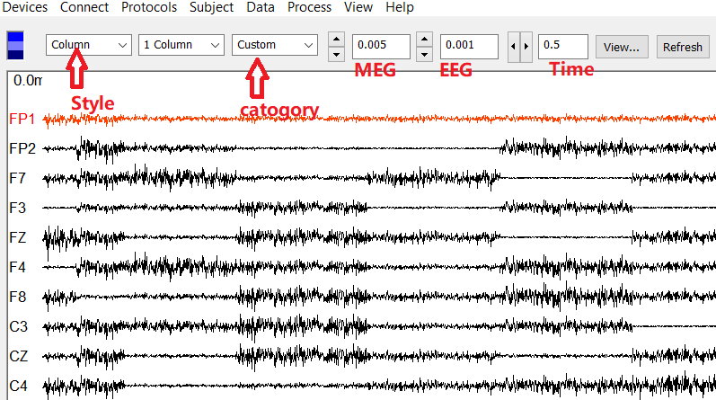Figure 4. GUI for selecting style, category and amplitude zooms (magnitude) for monitoring and recording. When you select a style, a channel set from the combo boxes, the individual channels that belong to the set will display in the strip chart, and the status bar will update to indicate the name of the displayed channel set. You can display only one channel set at a time, although you can restrict the display of channel groups within the channel set.

# Channel Types

Channel types vary among MEG systems. Here we provide the Channel Types from CTF MEG systems as an example. The following are possible channel types:

**STIM-REF**

Stimulus channel carrying trigger information.

**TIME-REF**

Time reference coming from the video channel or system clock.

**MEG-REF**

Reference magnetometer and gradiometer channels.

**MEG-SENS**

Sensor magnetometer and gradiometer channels.

**MCG-SENS**

Sensor magnetometer and gradiometer channels for magnetocardiography.

**EEG-REF**

EEG bipolar sensors.

**EEG-SENS**

EEG unipolar sensors (typically scalp electrodes).

**EKG (ECG)**

Electrocardiographic bipolar electrodes

**ADC-REF**

ADC current channels from the Head Localization Unit (HLU)

**ADC-VOLTREF**

ADC volt channels from the Electronics Control Console.

**DAC-REF**

DAC channels from the ECC.

**SUPP-REF**

Supplementary channels carrying channel reset information used for cross talk (CTF MEG 2005 system).

**POSITION-REF**

Continuous head localization (CHL) channels carrying x, y, and z position coordinates for the localization coils as well as displacement distance information for the Na, Le, and Re channels.

**OTHER-REF**

Any other type of sensor not mentioned but still valid.

# Sensor and Reference Channels

In most of MEG/MCG/EEG/ECG systems, ALL SENSORS, MEG-SENS, and EEG-SENS are standard, pre-defined channels sets that are used to display MEG sensor and EEG electrode data. Reference channels (*-REF) display data collected on the various types of reference channels, and are typically used for system diagnostic purposes.

# Continuous Head Localization Data

EEG/EKG typically do not need head localization. Head localization may need for MEG and MCG. In fact, not all MEG systems have, modern MEG systems typically have continuous head localization channels. In MEG system, the POSITION-REF channels contain Continuous Head Localization (CHL) data. Channels beginning with “HLC” display x, y, z positional data for each coil. The Na, Le, and Re channels are the vector sum of the x, y, z positional data for the nasion, left ear, and right ear head localization coils, respectively. The FIT-ERR channel type displays the fit error for the coil positions over time. Fit error is the criterion for “goodness of fit,” and provides an indication of how reliable the CHL data is. When displaying CHL channels, the software also allows you to view CHL data relative to default coil positions saved in the dataset during the head localization pre-run, so you can see the displacement from these default positions over time.

# Displaying Channel Sets

A channel set is a collection of channels, such as the set of all MEG sensor channels or MEG reference channels. AcqManager has several pre-defined channels sets, and allows you to define new ones by allocating channels to a named collection of your own. A channel can belong to more than one channel set. The Set menu in the main window menu bar displays the available channel sets for the current dataset.

# User-defined Channel Sets

User-defined channels sets can be created from the Channel Select Dialog, which displays when you click Channel Selector button.

# Displaying Channel Groups

AcqManager also has pre-defined channel groups, which reference specific collections of channel sensors, such as the MEG Left sensors or the MEG Right channels. As with channel sets, you can also define new channel groups of your own. The Group combo box in the main window bar displays the available channel groups, as shown in Figure 4. These combo boxes allow you to control which groups of channels are displayed within a channel set. Select Show All to enable the display of all channels in the current set, regardless of their grouping. You can define new channels groups from the Group Set dialog, which displays when you select Channel Grouping from the Display Combo Boxes.

# Channel Selection Dialog

A third method of selecting the channels to display is to choose them by channel set and/or individual channel name in the Channel Select dialogYou can also define new channel sets using this dialog. To add or remove individual channels from the Selected list, highlight them in the Unselected or Selected lists, then use the appropriate arrow button to move them over. When you click Apply or Ok, the selected channels will display in the strip chart.

# Selecting Channel Groups

You can overlay all traces belonging to the same channel group (e.g. left and right groups), then select them from the overlay panel by clicking on the channel group name. When you select a channel group, its individual traces may display as red lines in the overlay panel and waveform columns, and as white circles in the map, which depends on the edition you have.

# Scaling the Time Axis

This section explains how to change the time scale in the stripchart (the x-axis). AcqManager provides the following ways to scale the time axis:

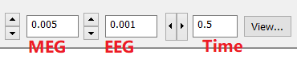Figure 6. Time and amplitude scale controls.

To stretch out the traces by a factor of two, click the right Time Scale arrow button in the control bar. To compress the time scale by a factor of two, click the left Time Scale arrow button. You can also set the time scale by entering a value (in milliseconds per centimeter) in the Time Scale edit field. These controls are shown in Figure 6.

# Scaling the amplitude of waveforms

This section explains how to scale the amplitude scale (gain) of the waveforms (the y-axis). To double the amplitude of the channel traces, click the “Increase” gain button in the control bar. To divide the gain by a factor of two, click the “Decrease” gain button. You can also set the gain by entering a value in the “Amplitude Scale” edit field. These controls are shown in Figure 6.

# Dialog for waveform display settings

The amplitude scale for displaying variety groups of waveforms can be set precisely with the Dialog for Waveform Display Settings (Figure 7). Noteworthy, the time scale for all waveforms is the same. You may set the scales by entering value in the corresponding edit field.

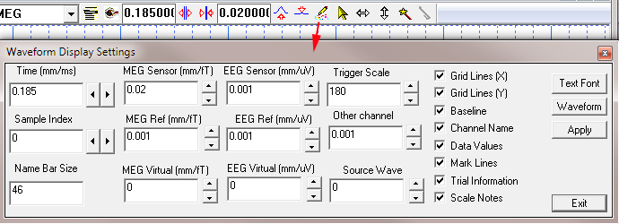

Figure 7. Waveform display settings.

# Define a range for viewing

To view data from a pre-defined data point, you may enter the sample index. The range of samples will be automatically decided according to the time-scale and the size of display window.

# Define background and other parameters

As shown in Figure 7, you may decide the Name Bar Size and whether or not to show Grid Lines (Time-X, Amplitude-Y), Baseline, Channel Name, Data Values, Mark Lines, Trial Information and Scale Notes.

In addition, the dialog provides also the GUI for changing Text Font, Waveform color and width.

# Acquisition, Monitor and record

AcqManager provides GUI for easy operation by simply clicking a few buttons. The buttons are shown in Figure 6. The “Reset” button internally reset all data acquisition parameters. To setup data acquisition, a simple click of “Acq” button can show the dialog for acquisition setup. The “Monit” button is used to start data monitoring. The “Record” button is used to record data which will store the data physically to the hardware or any storage that is defined in the dialog of acquisition. The “Stop” button stops all data monitoring or recordings. To exit the program, the user can click “Exit” button.

Figure 6. Operational buttons. To setup data acquisition, a simple click of “Acq” button can show the dialog for acquisition setup. The “Monit” button is used to start data monitoring. The “Record” button is used to record data which will store the data physically to the hardware or any storage that is defined in the dialog of acquisition. setup

# MEG/EEG Montages (CxC)

Conventionally, “Virtual” channels are used to create EEG montages, where each EEG channel may be re-referenced either to the average of all EEG channels or to a neighboring channel. The development of computer technology makes it possible to generate a Channel-cross-Channel (CxC) matrix to represent that each MEG/EEG channel is re-referenced to all other channels. By generating a CxC matrix, user can check all possible MEG/EEG Montages.

You create CxC using Wave Form Coherence Dialog, shown in Figure 13. This section illustrates some shortcut methods for defining CxC Matrix. For more information about creating CxC matrix.

In this Manual, we use “virtual channel” to describe a channel computed by two physical channel (e.g. MEG measuring channel or EEG channel). Here the computing may be an operation of addition or subtraction of two channels. On the other hand, “Virtual sensor” is typically used to describe a sensor placed in a source level, which is computed with a group of physical sensors. In other words, a “virtual sensor” is based on source localization. Here the physical sensors are usually included in the channels.

**Index**

E

Electroencephalography (EEG), **5**

F

femtoteslas, 6

M

Magnetic source imaging (MSI), 5

Magnetoencephalography (MEG), 5

Main Frame, 6

P

picoteslas, 6

T

Teslas (T),, 6